Terraform Task

Task Description:
Launch Linux EC2 instances in two regions using a single Terraform file.

Terraform installed on local machine:
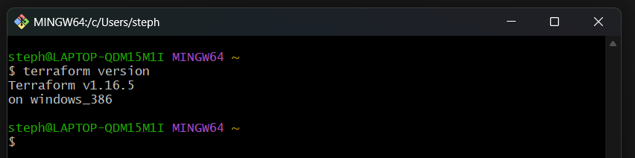

AWS CLI installed and aws authentication has been enabled:
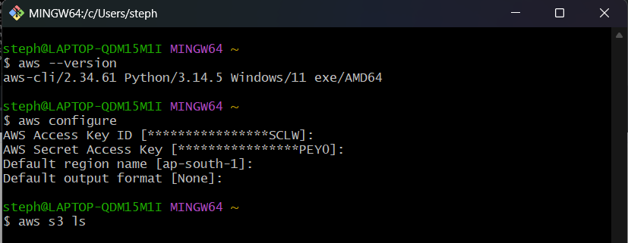

Initialize Terraform:
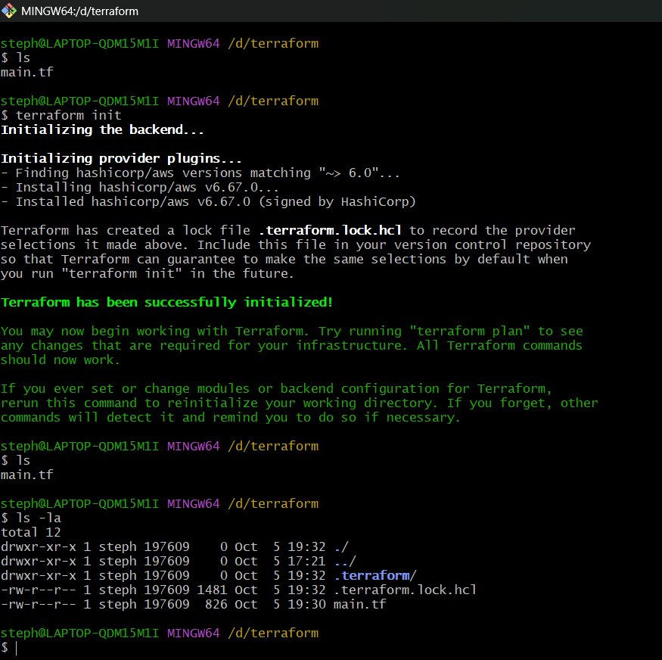

Create Terraform script:
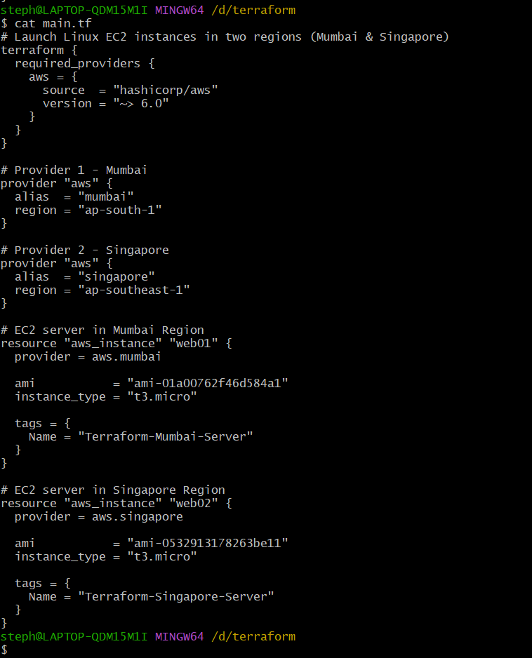

Creating Linux EC2 instances in two regions:
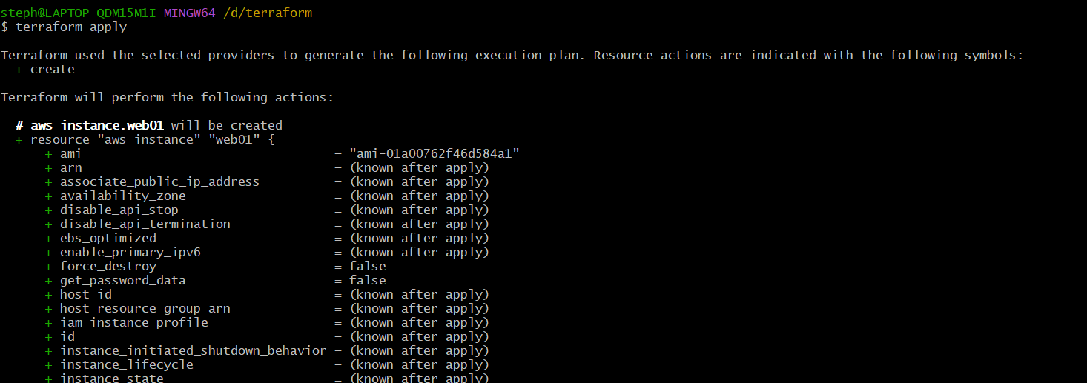
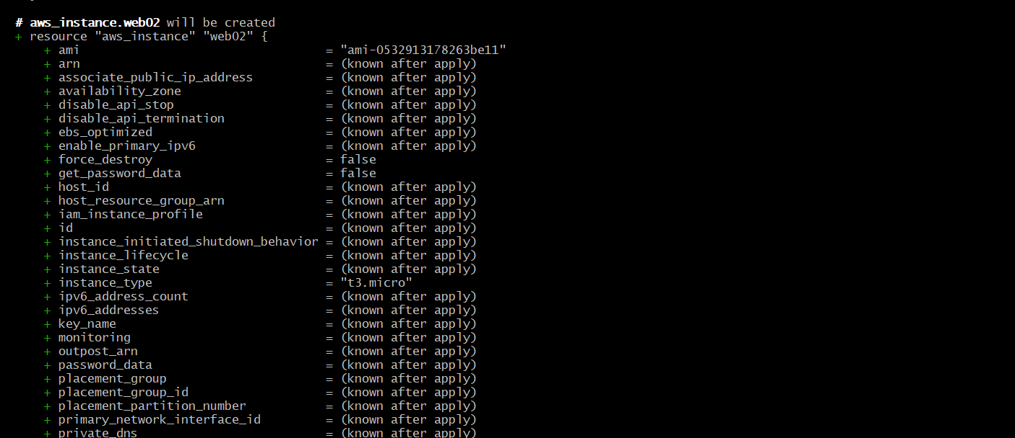
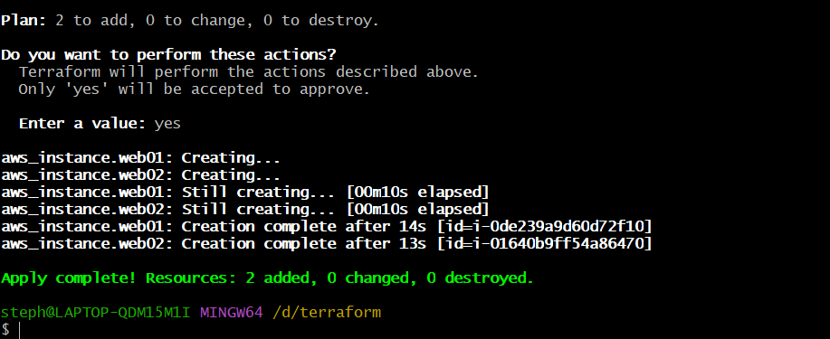
Below list out the Created Linux EC2 instances in two regions:
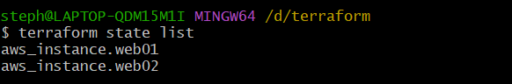
aws_instance.web01: Mumbai Region
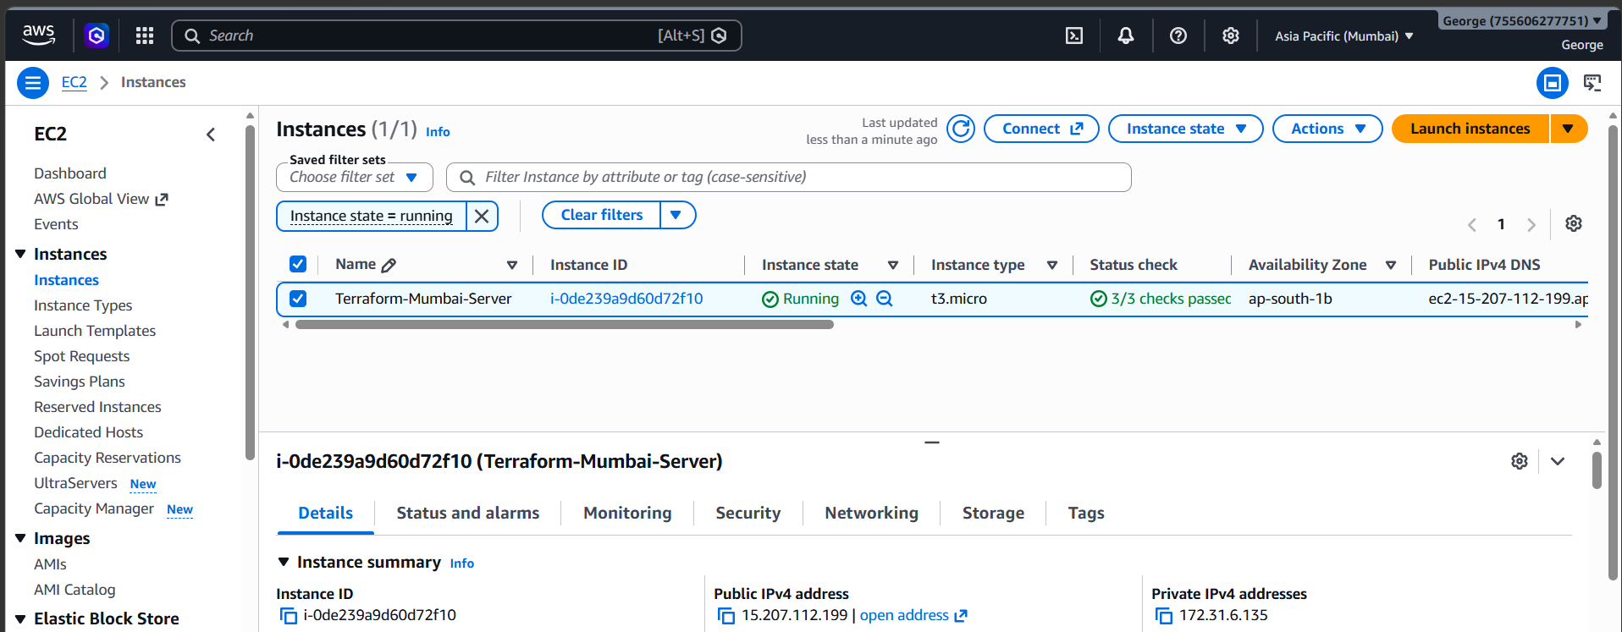

aws_instance.web02: Singapore Region
